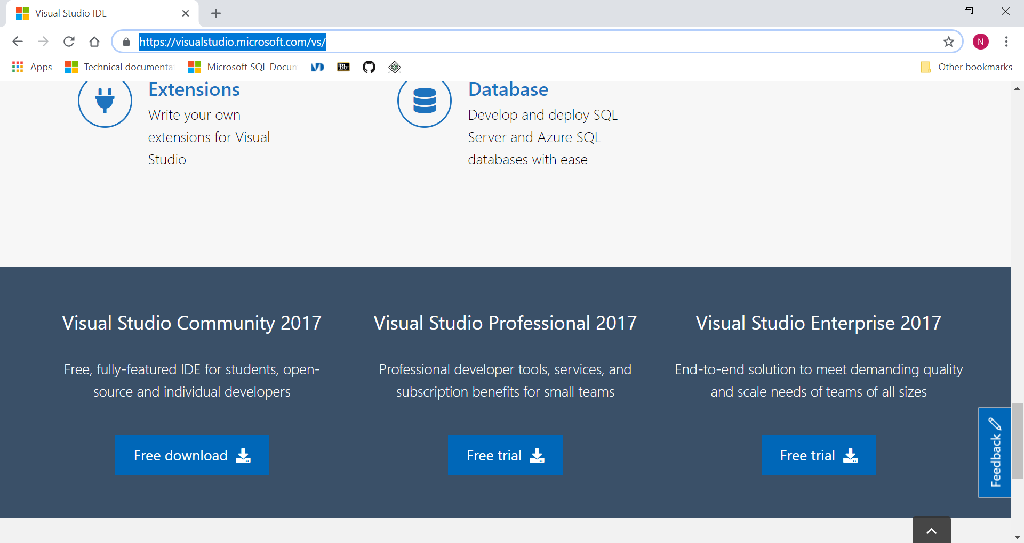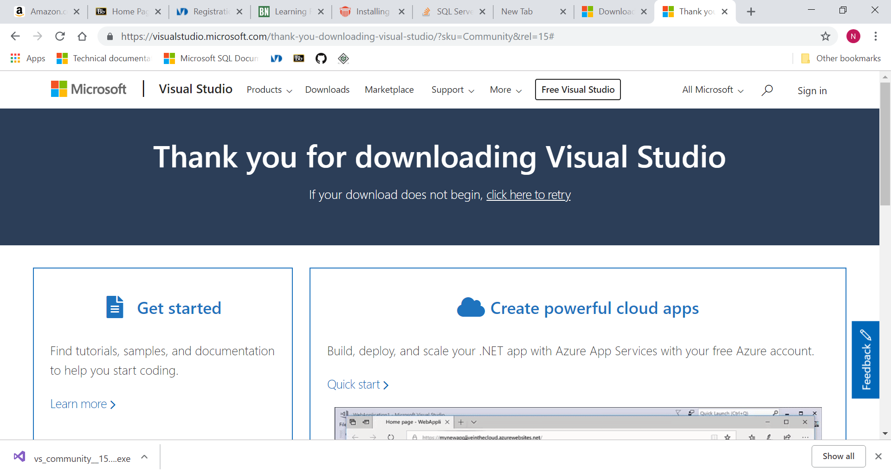

I download the installer from the Microsoft Visual Studio from **https://visualstudio.microsoft.com/vs/.**

I am using the Visual Studio Community Edition.

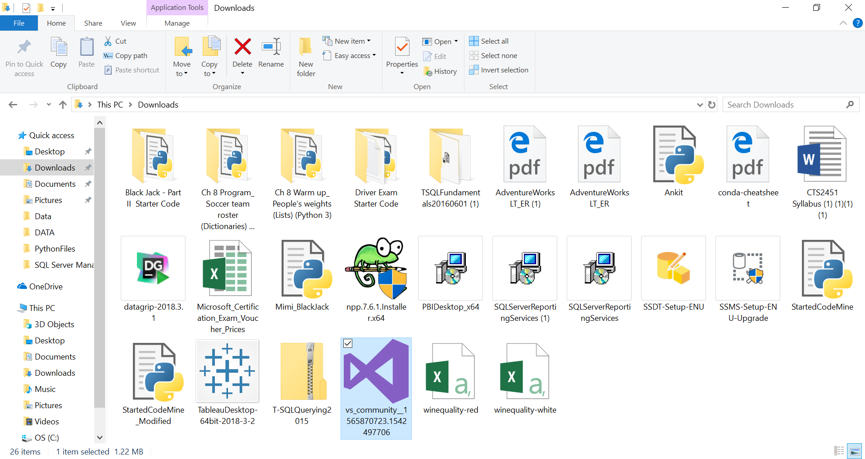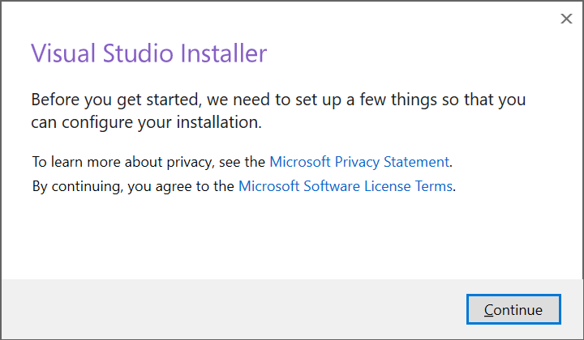

I then go to my downloads folder and run the executable file.

The Visual Studio Installer window displays and indicates that there will need to be files set-up to do configuration on the installation.

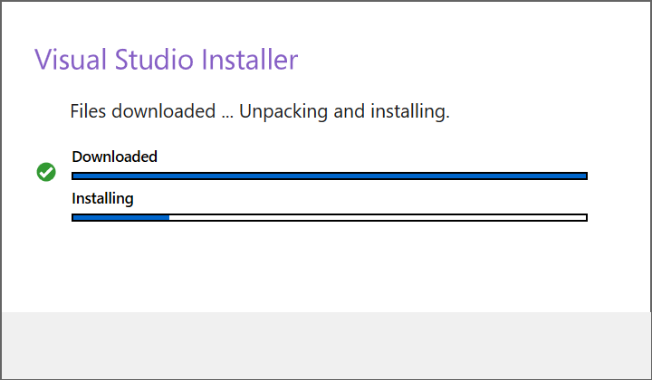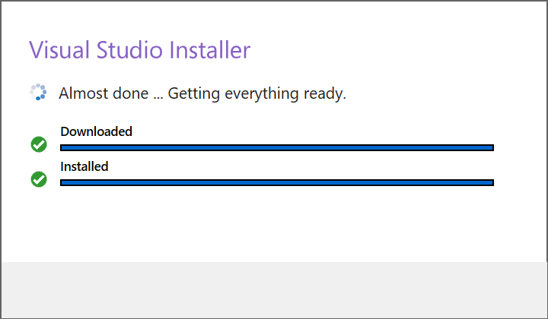

After selecting continue, the installer begins the set-up.

Above are pictures of the progress and the completion of the set-up.

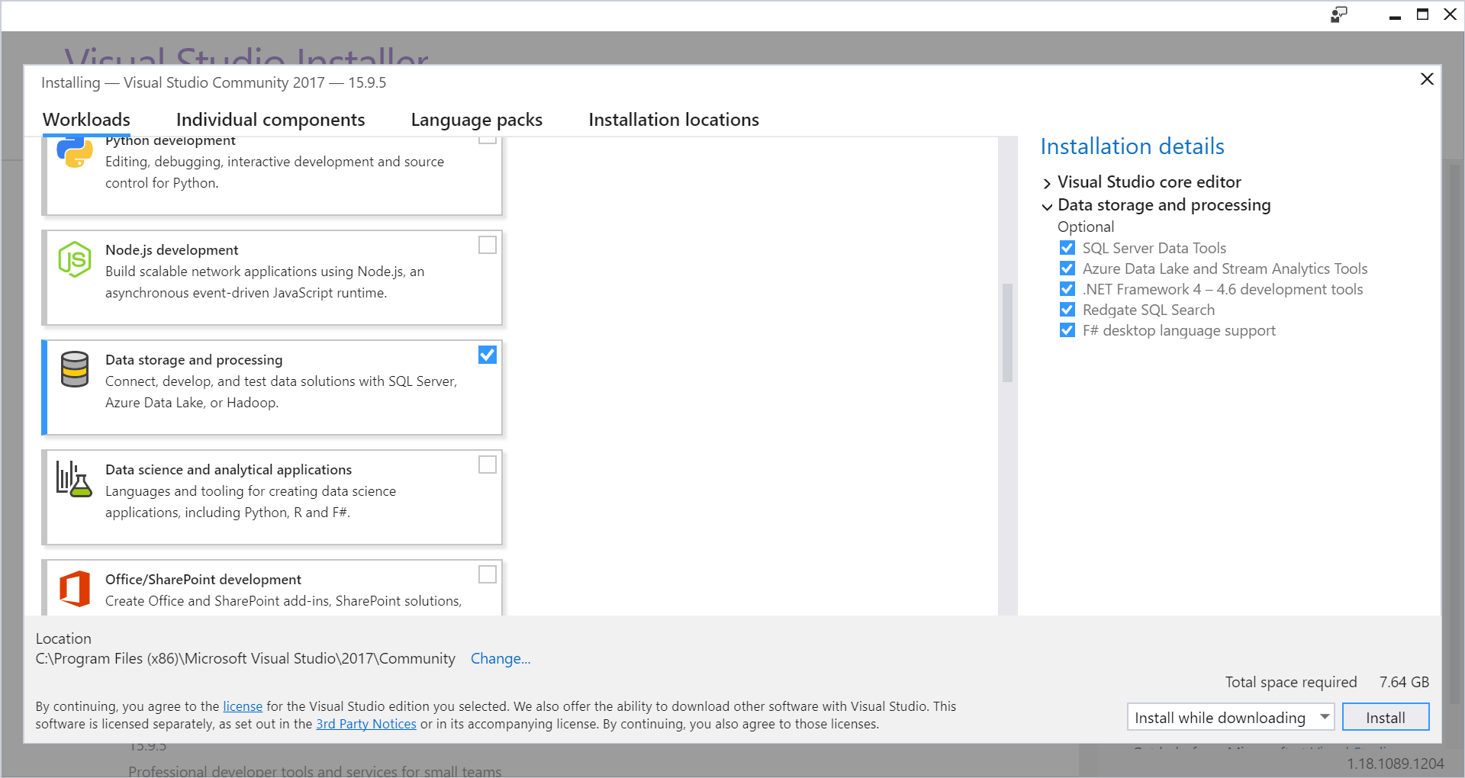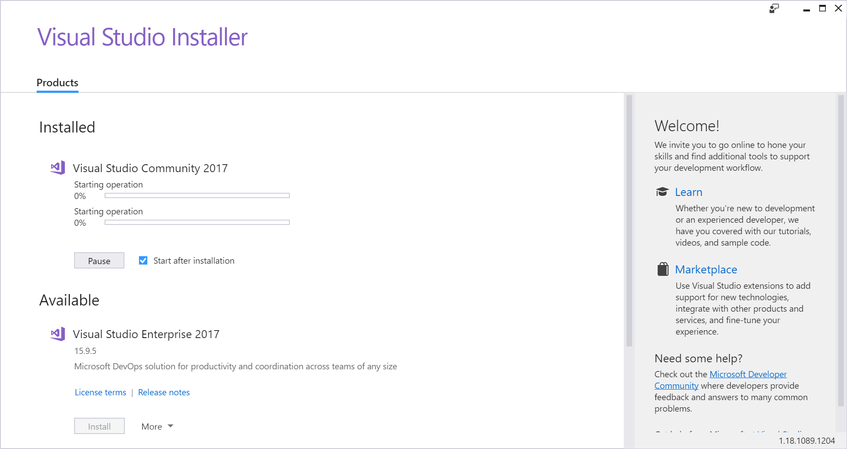

After the set-up process, we are then prompted to install the components of Visual Studio 2017 that we would like. We can do this by **Individual Component** or by **Workloads**, by going to the selected tab.

I do this by the **Workloads**, I then select the **Data Storage and Processing** workload and I select all the optional components in the Workload, which includes the SQL Server Data Tools (SSDT).

After selecting install, we are placed in the installer menu where we can see the progress of the install, shown above.

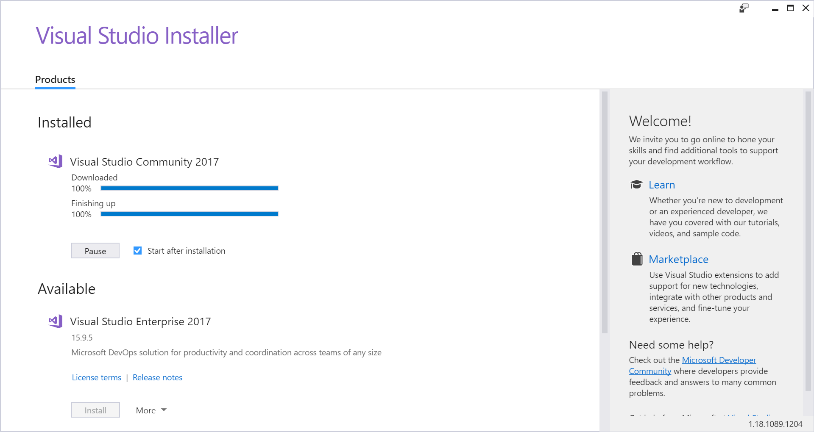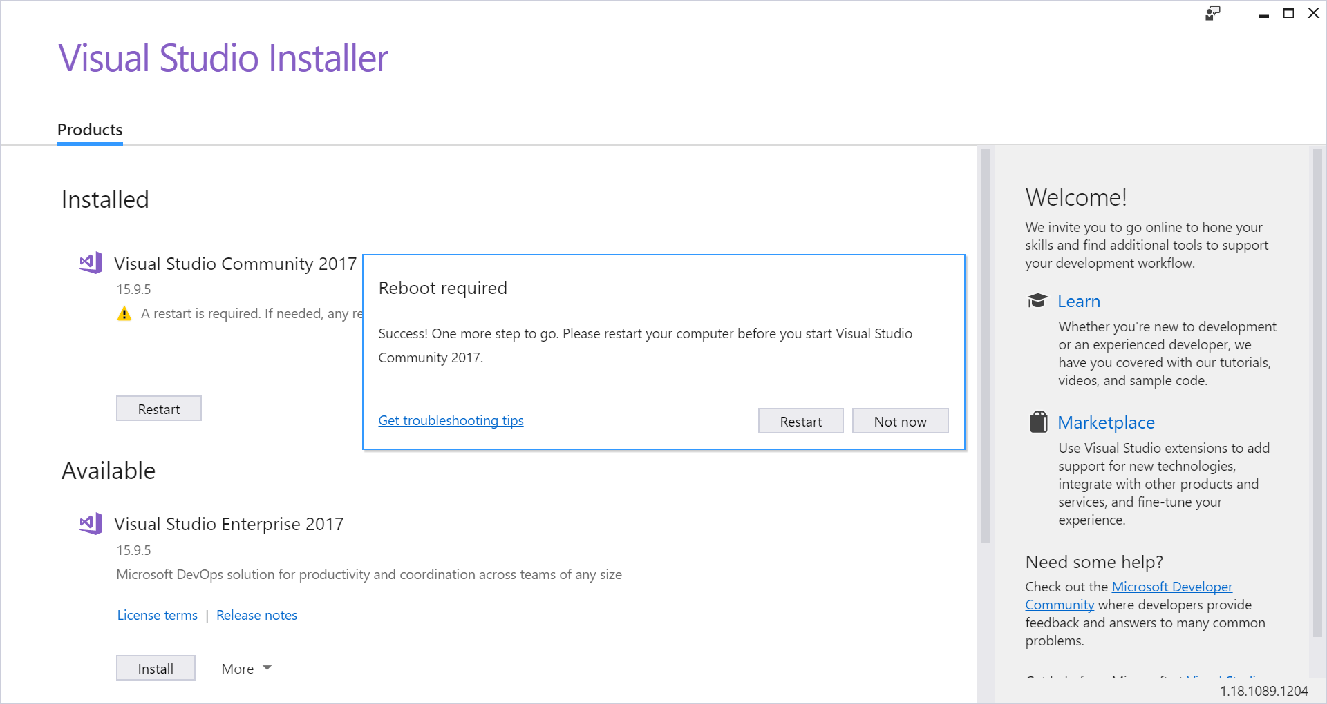

The install of all the components in the **Data Storage and Processing** workload take a few minutes as it is almost 8 gigabytes.

After the install the Visual Studio 2017 installer prompts a reboot of the computer.

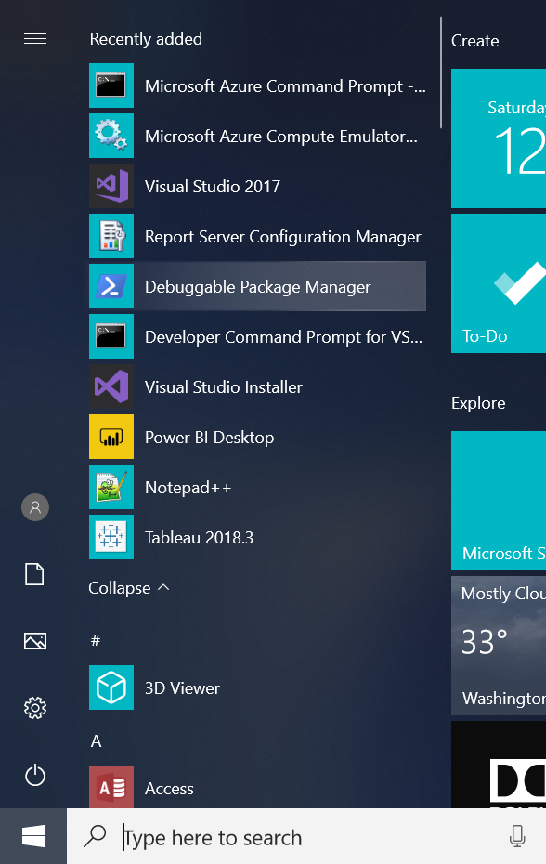

After the Reboot we can see that the program is now in the Start Menu as well as some other optional components from the workload.

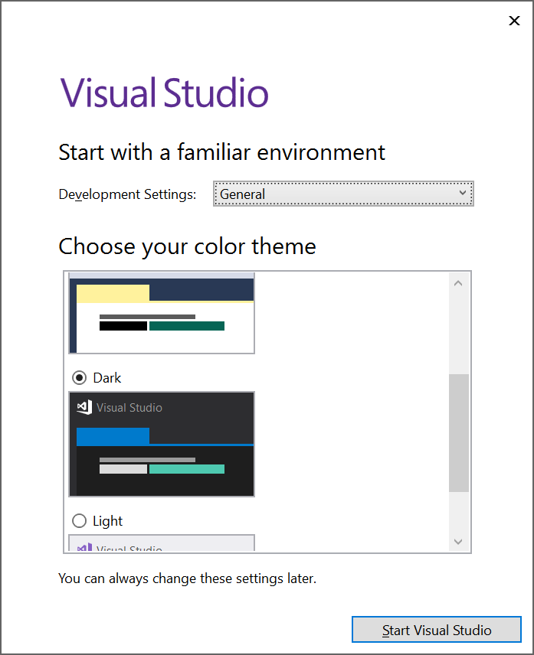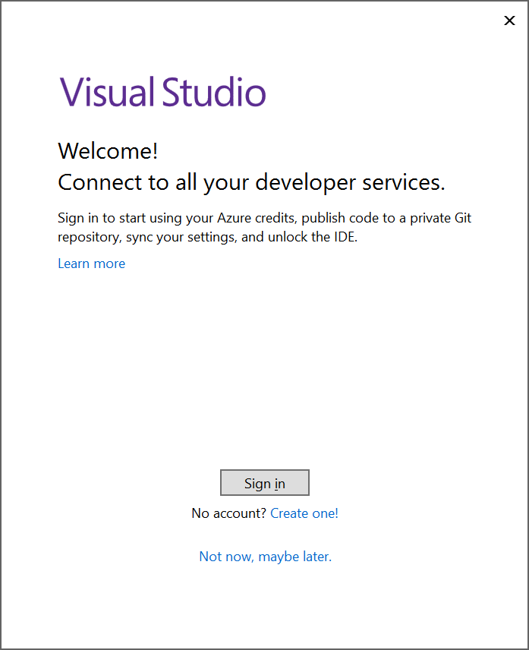

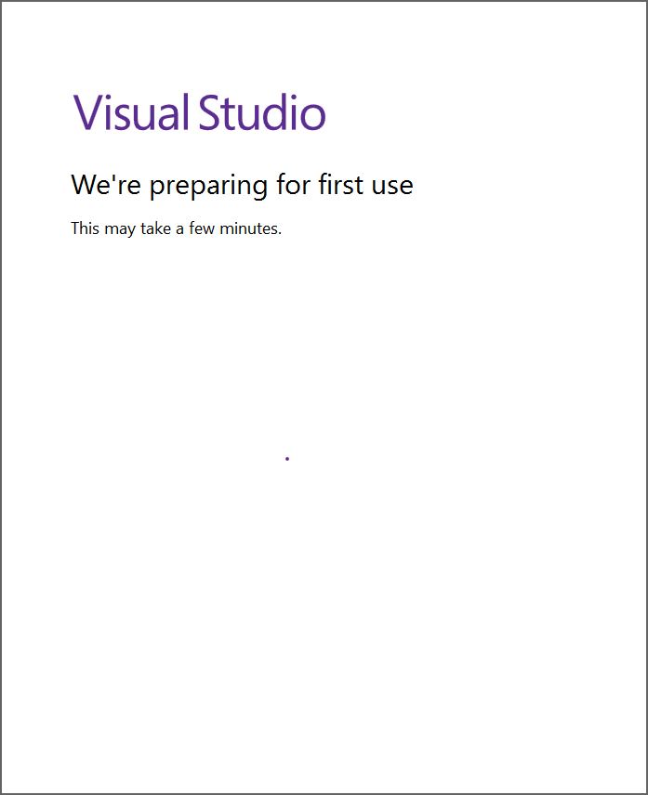After executing the new Visual Studio 2017 install we are prompted to go through first time set-up of the program.

The user can sign-in to their Microsoft account as well as select the Development Settings and color theme of Visual Studio.

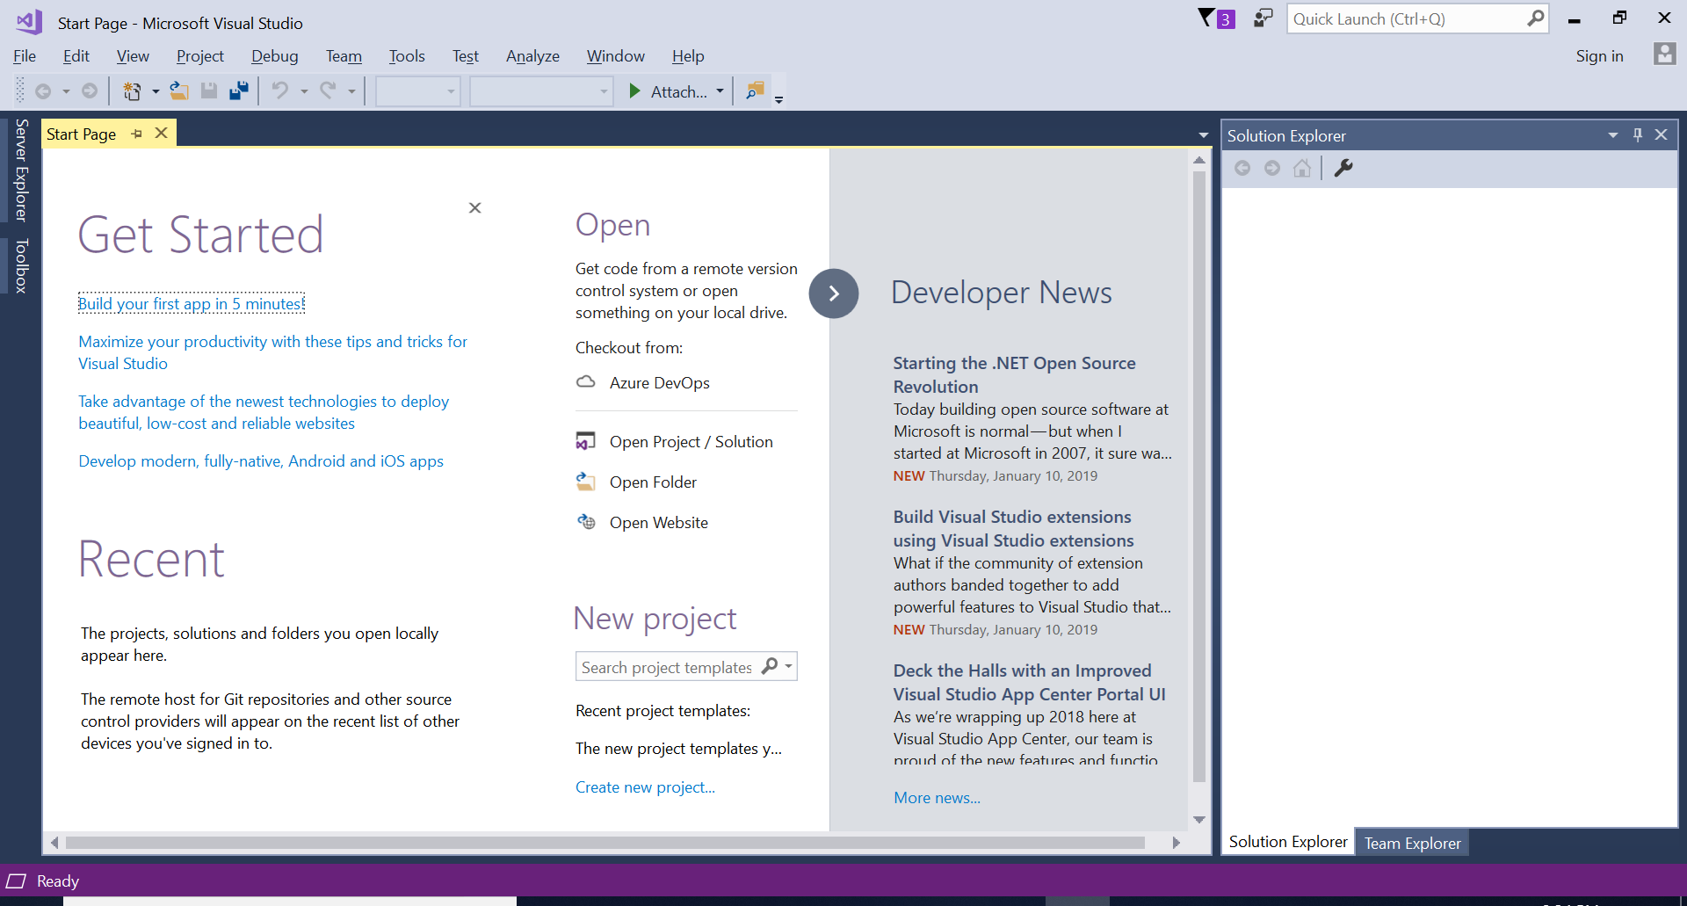

After first time set-up is complete, we are taken to the Start Page of Visual Studio where we can begin connecting to a SQL Server Instance and database.

Now, I need to complete the set-up of the Galactic database by retrieving a backup file (.bak) online and connecting it through the SQL Server Management Studio and restore the file. I do this by going to the official website of the book following the download directions.

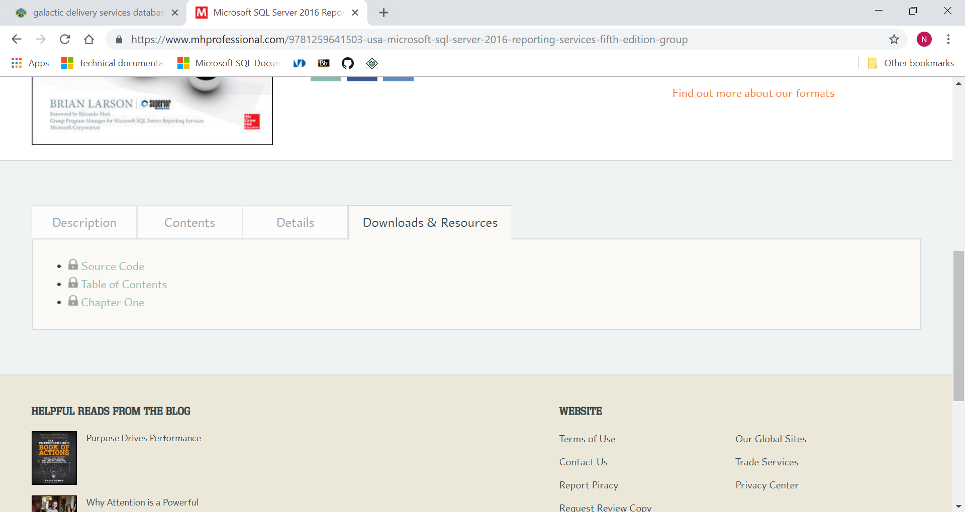

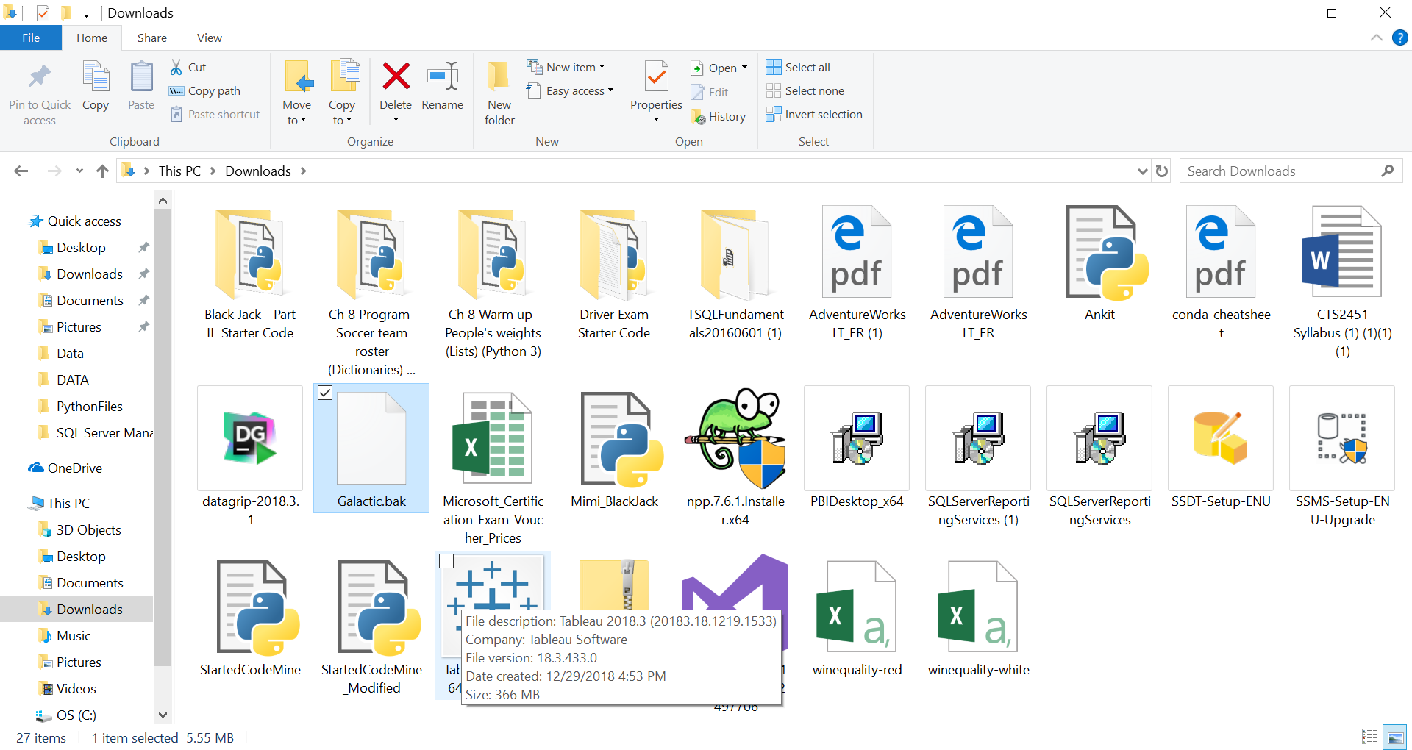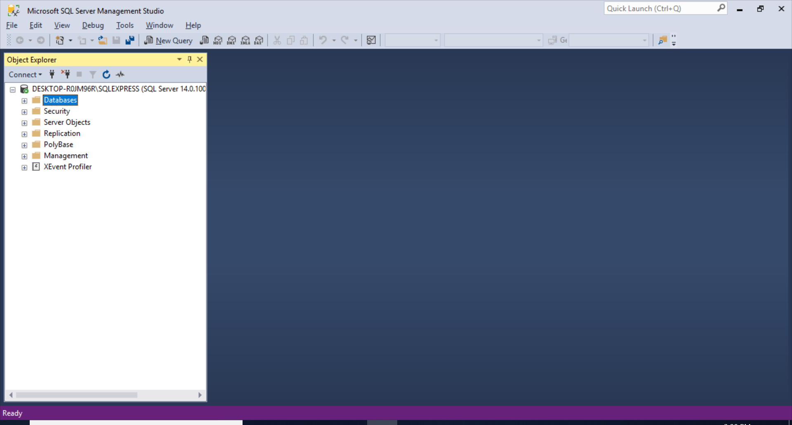

I am able to download the backup file for the database, as shown in my downloads folder.

After obtaining the Galactic database backup file from the official website, I then open the SQL Server Management Studio in order to restore the file.

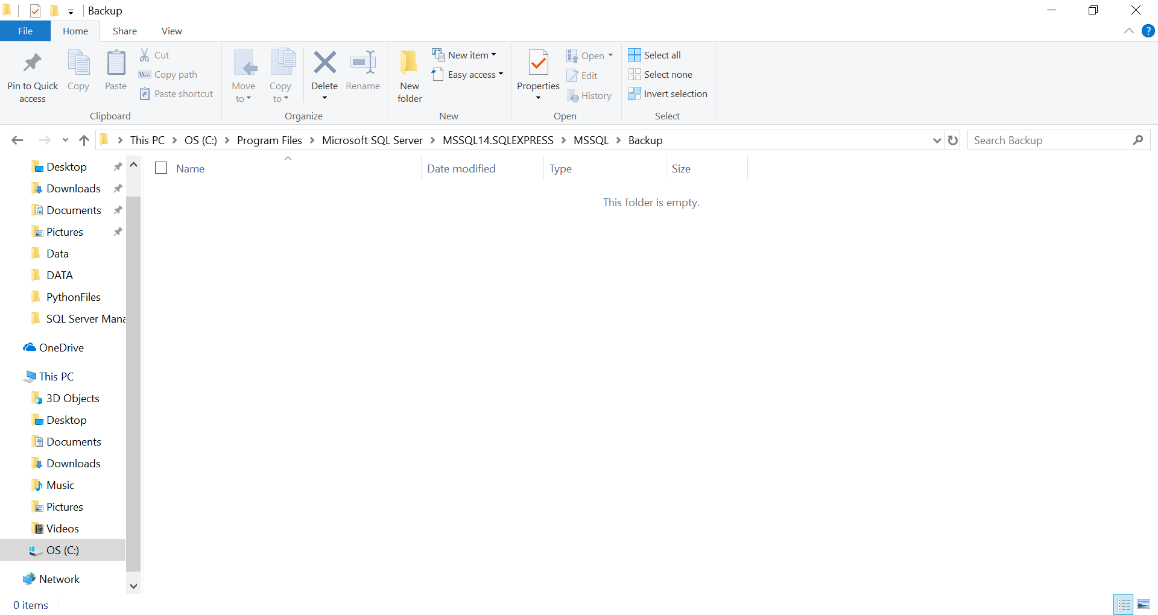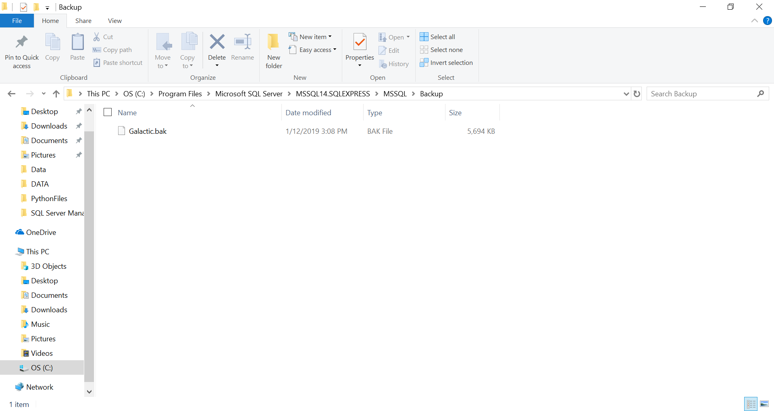

Before I begin to restore the Galactic database, I must place the backup file in the default location where SQL Server retains the backup files.

The location of the backups is:

**C:/Program Files/Microsoft SQL Server/MSSQL14SQLEXPRESS/MSSQL/Backup**

I copy the file into the default location for backups and now I am ready to return to SQL Server Management Studio to finish the backup process.

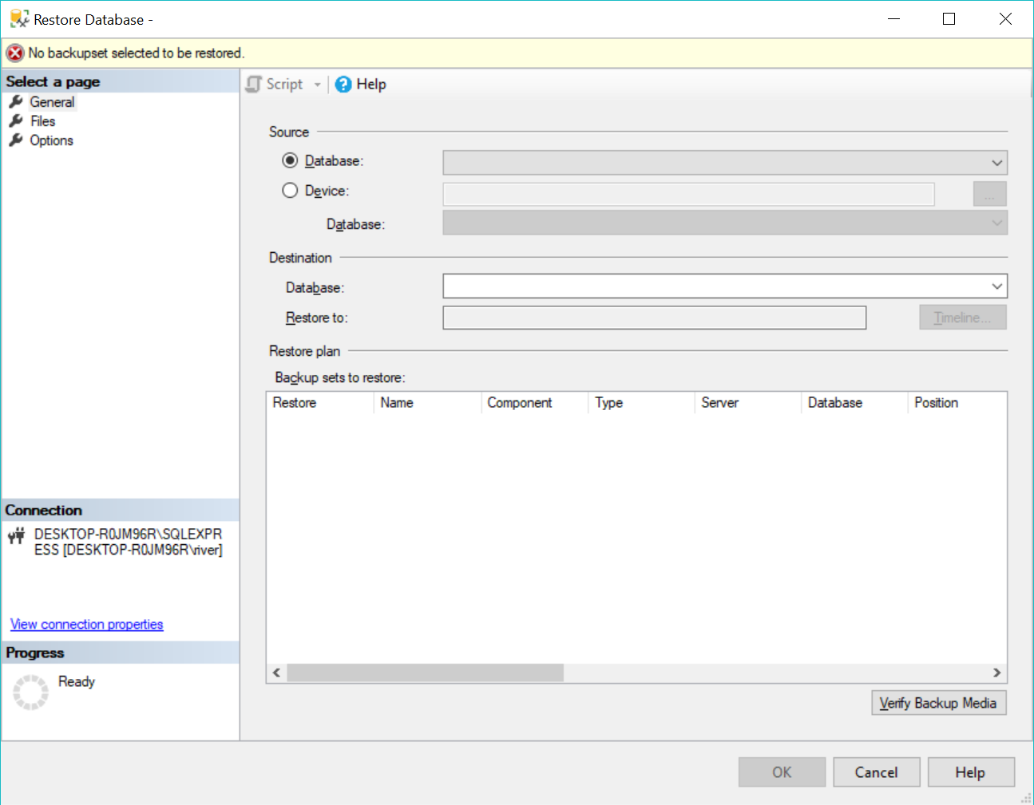

To begin the restore process, I do this by right-clicking the databases and selecting the Restore Database option in the Databases folder in the Object Explorer in SQL Server Management Studio.

Under the Source section, I select Device as there is no database called Galactic and we are restoring using a backup file.

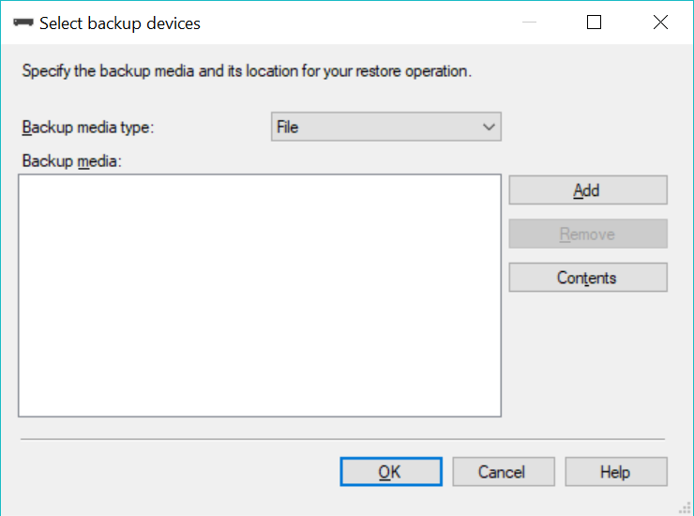

I select Add button in order to add the .bak file to the list of backup media.

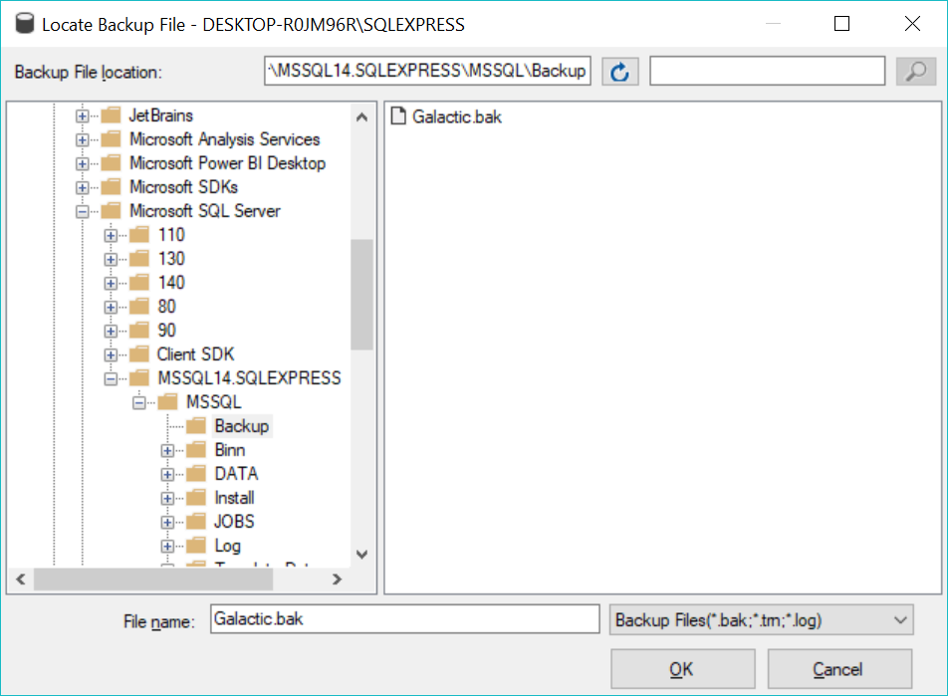

I select the Galactic database to be added to the backup media.

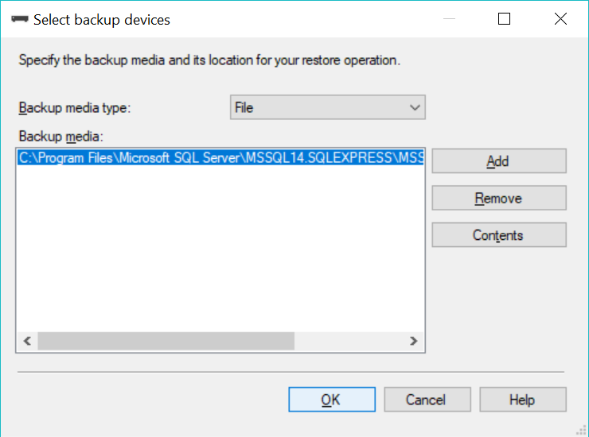

You can see the backup file added after selecting it from the backup folder. I confirm the choice and return to the main page of Restore Databases.

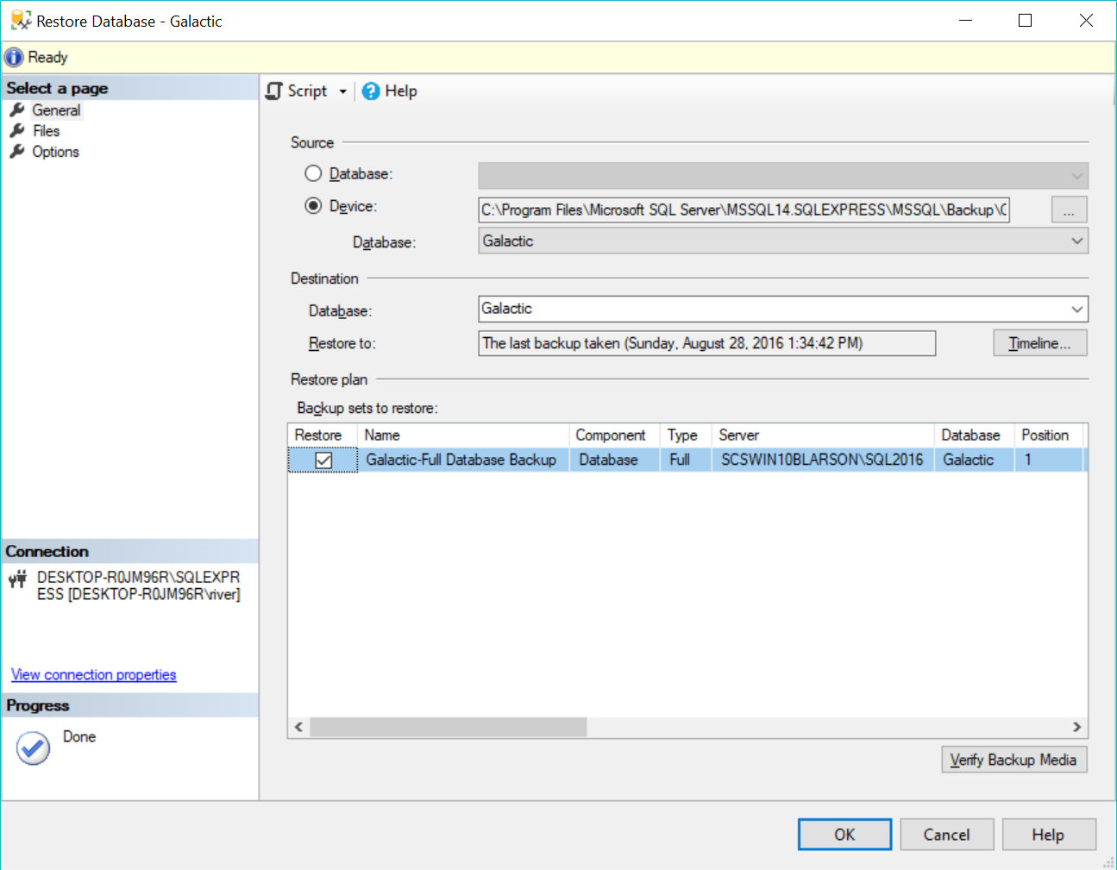

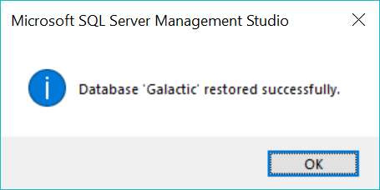

Now that we are back to the main window of the Restore Database, we can confirm the selection. We can see that we have successfully restored the database.

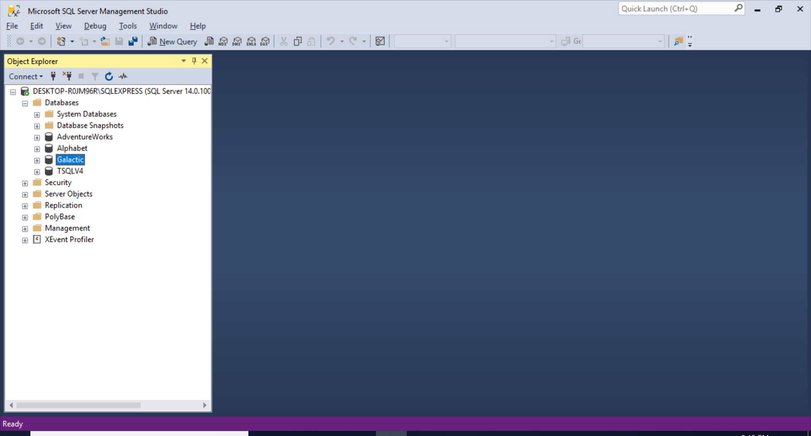

We confirm that we have attached the database to the SQL Server instance.

I return to Visual Studio 2017 and I connect to the SQL Server Instance in the computer, from there I then created a connection by right -clicking the server name and selecting Add Connection.

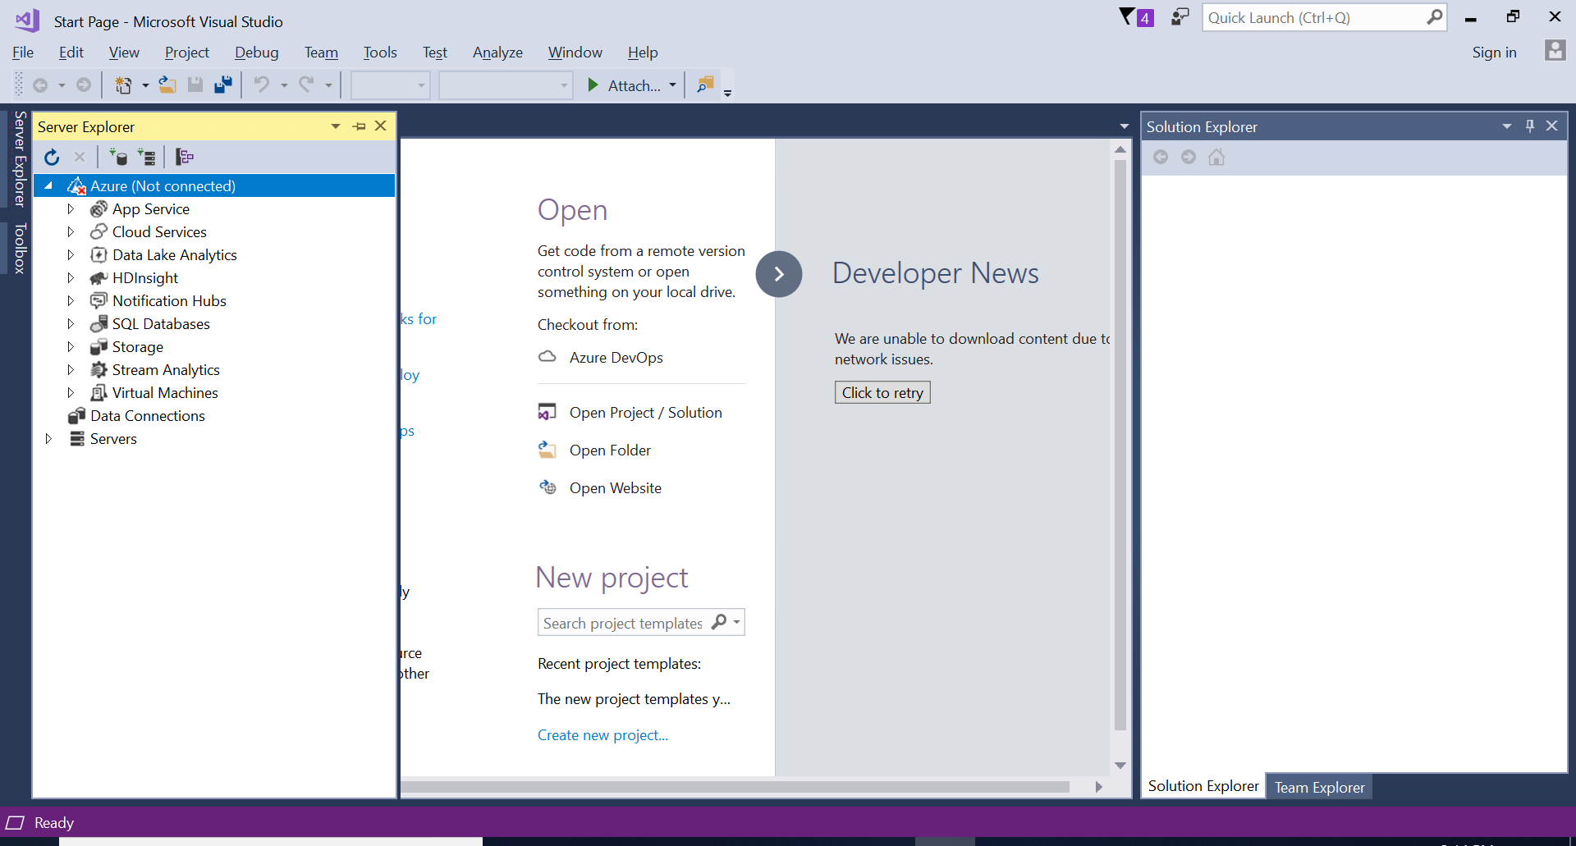

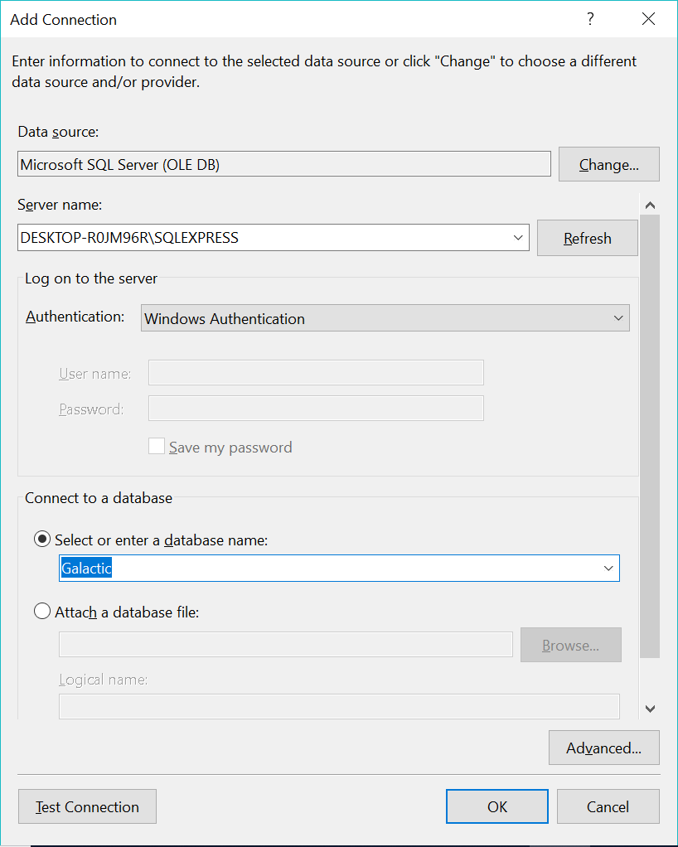

In the Add Connection window, we add the server name within our SQL Server instance, we may have t refresh to see the server. I confirm the Authentication is Windows Authentication. I then select the database I want to add to my list of connections.

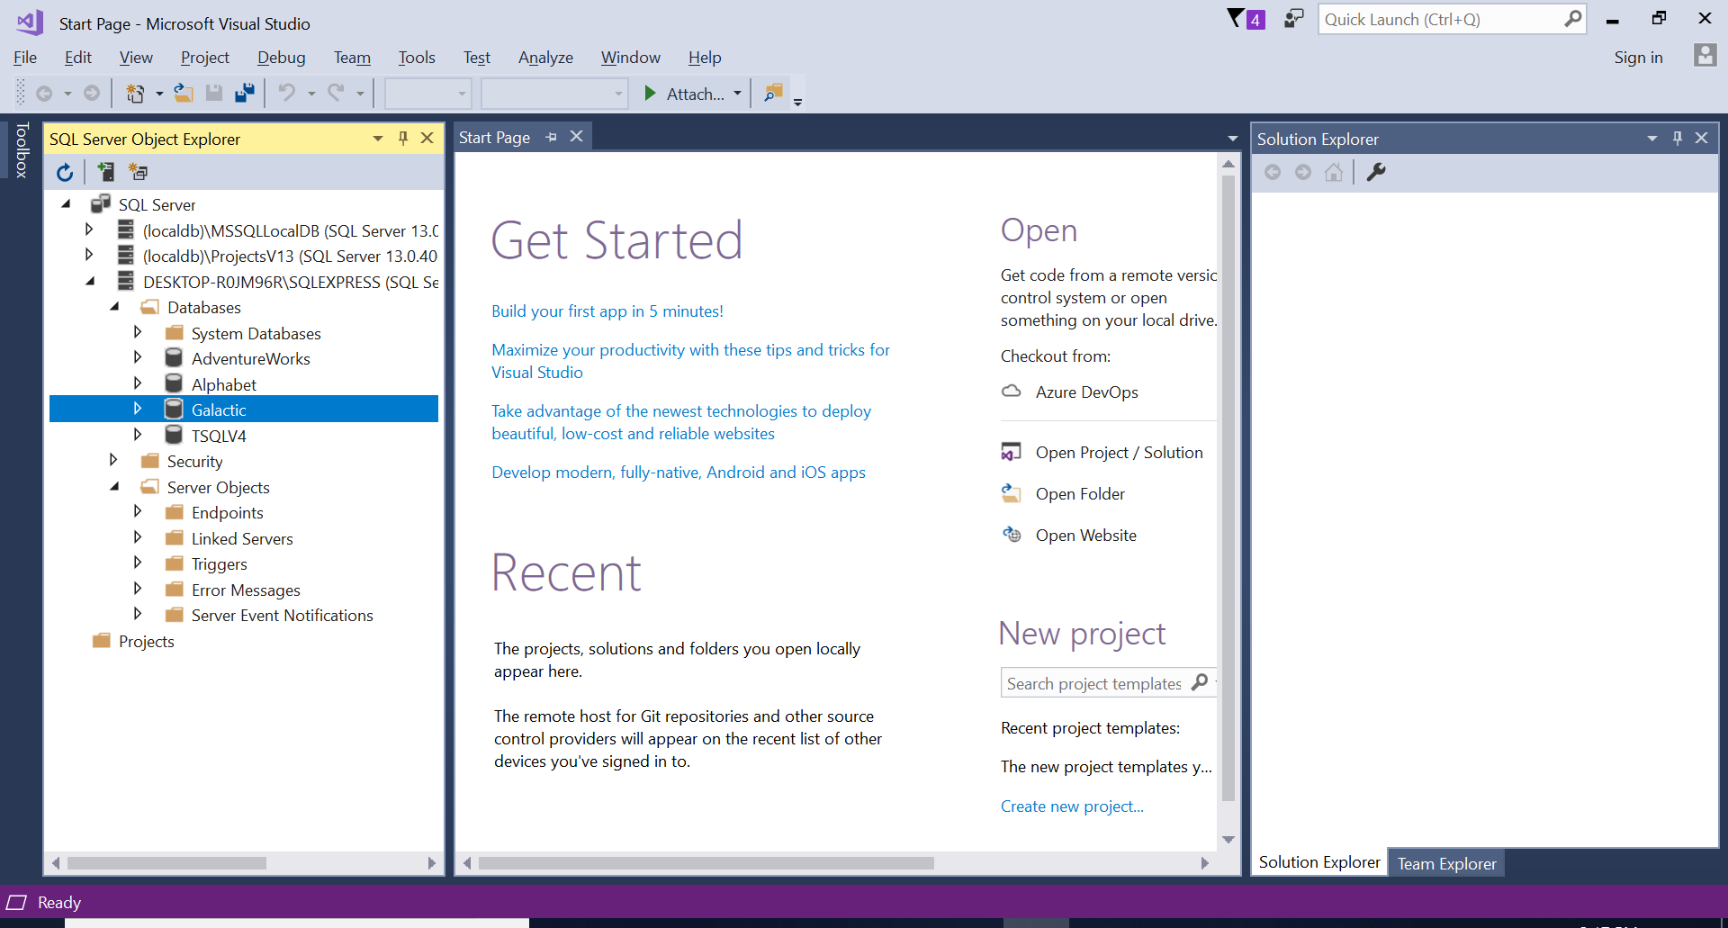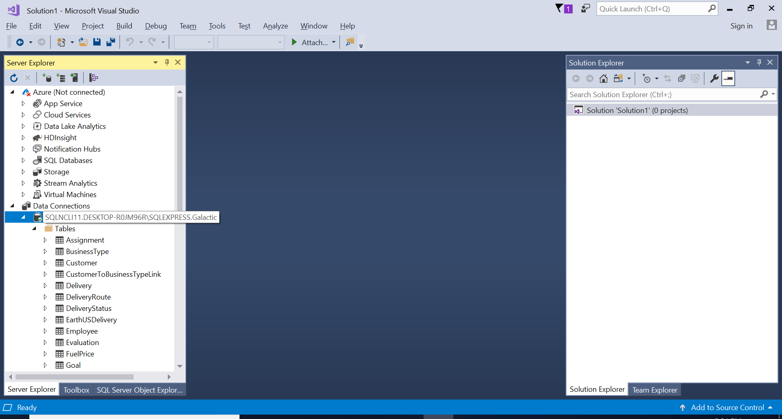

Finally, I check the SQL Server Object Explorer window in order to confirm the Galactic database is attached. You can see that the database has been attached without issue.

The Galactic Database is now ready to be used.